**Reconciling geographic locations of survey stations:**

The five pelagic surveys under review were not designed in a simultaneous or coordinated effort, but rather were initiated between the 1950s and 200s to address questions specific to the ecological and management context of their respective eras. As such, in many ways the surveys are independent entities, but many efforts to coordinate between surveys have occurred through the decades resulting in a challenging situation in which some aspects of the surveys are logically related, but many others are not. One area that poses is challenge is the naming convention for survey stations. Each survey uses a three-digit identifier for each station, and 60 station identifiers are shared by at least two surveys (2 surveys: 21 stations, 3 surveys: 5 stations, 4 surveys: 5 stations, 5 surveys: 29 stations). In most cases, when the same identifier by multiple surveys the geographic location is shared, but there are numerous exceptions to this pattern. Integrated analysis of catch data requires reconciling which station identifiers differ in location between surveys. However, this process is inherently somewhat subjective, since the dynamic conditions of the Delta and practical challenge of towing nets through this environment mean that the recorded locations of sampling stations must be understood as approximate. Moreover, the practical relevance of a given geographic discrepancy will vary across regions, with minor variation in location unlikely to be of much importance in open water regions, but potentially more impactful in channel and slough areas. As such, there is some scope for minor variation in the station coordinates between surveys, but such variation must be considered on a case-by-case basis.

In total, 190 station identifiers have been used across the five surveys. We first selected only stations for which the identifier was used in at least two surveys (n=60). We next calculated the minimum and maximum decimal longitude and latitude recorded for each of these station locations, calculated the absolute value of the differences between each pair of values, and summed the results to derive a rough metric of total geographic variability for a station identifier. We next removed from further examination all stations for which the total discrepancy was less than 0.01 degrees, determining through visual inspection that differences smaller than this were within the likely range of variation typical for these sampling methods. After these exclusions, 25 stations remained with potentially consequential distances between survey locations. To allow for visual comparison at an appropriate resolution, we divided these stations into four groups and plotted the station coordinates on a map of the Delta.

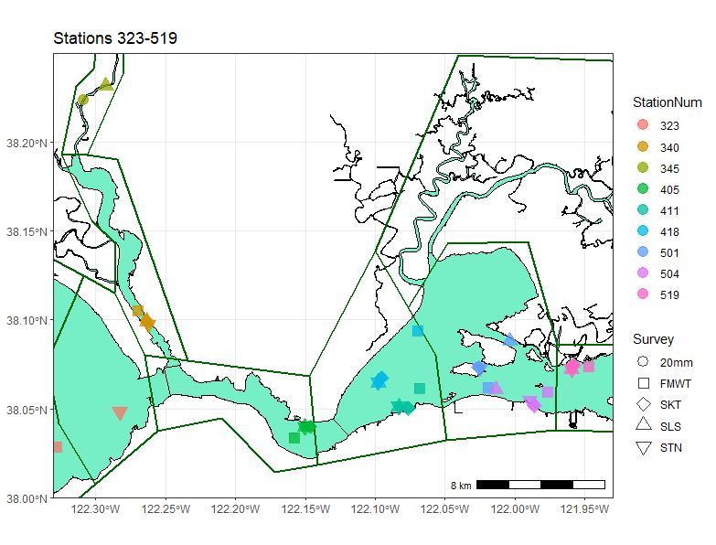

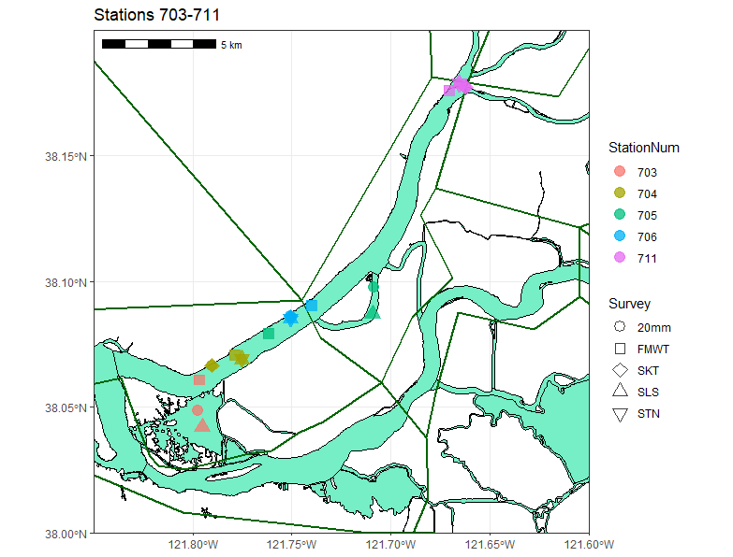

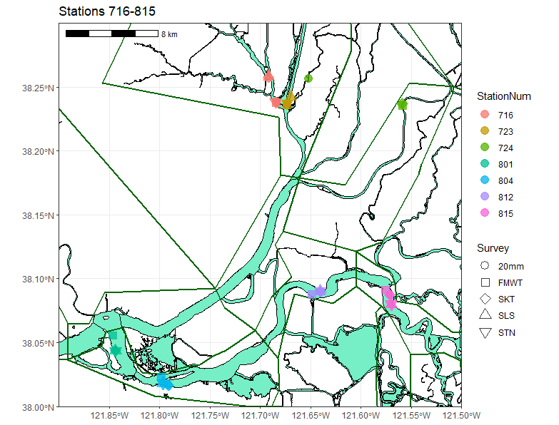

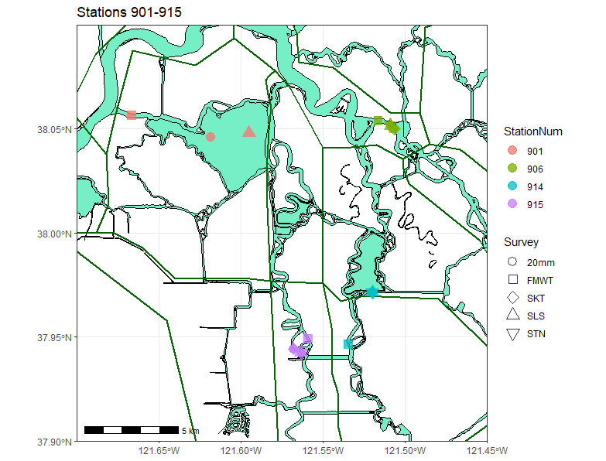

Initial conclusions from examining maps:

* 340, 519, 405, 711, 704, 706, 804, 812, 723, 815, 906 can **probably be grouped** as one location.
* 716, 801, 345, 411, 504 have somewhat greater geographic spread but could **potentially** be combined.

**Remaining stations will need to be split into at least two locations:**

* 724(20mm in separate channel),
* 901 (Potentially all unique locations),
* 915 (FMWT in different channel?),
* 914(FMWT very far off),
* 705(FMWT in main channel, others inside channel),
* 703 (FMWT not in Sherman Lake, others are), 323 (STN and FMWT 5+km apart),
* 418 (FMWT several km separate),
* 501 (surveys spread on different sides of islands)